Assignment 6
Slide 1
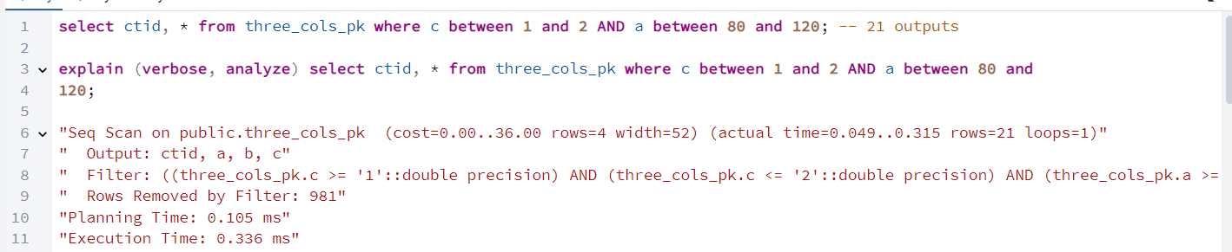
Slide 2
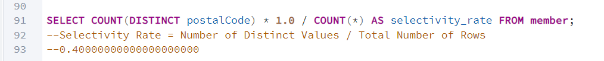

Slide 6
N1
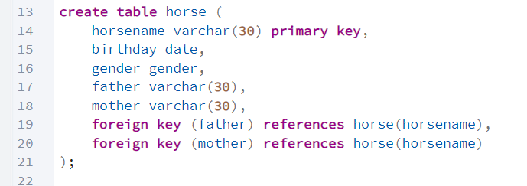

N2
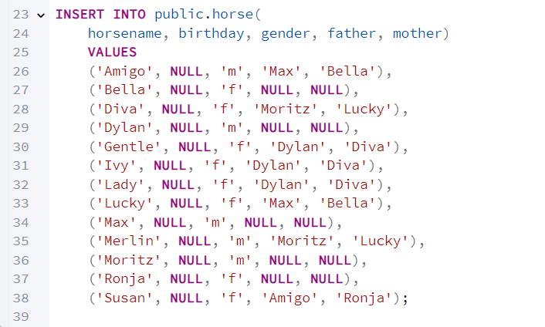

N3

N4
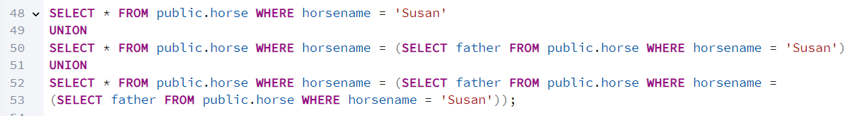
N5
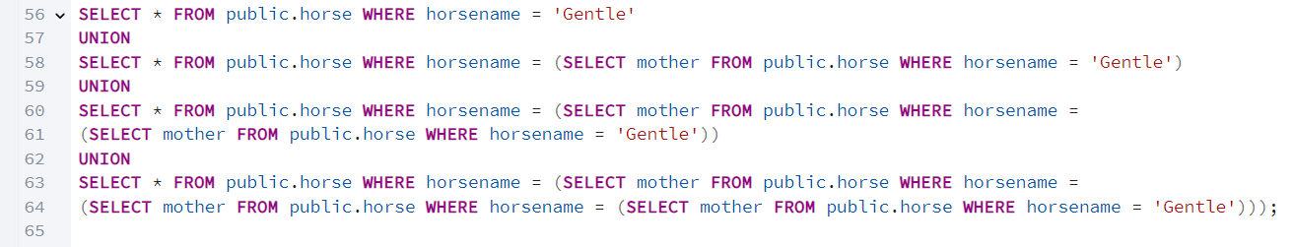
N6
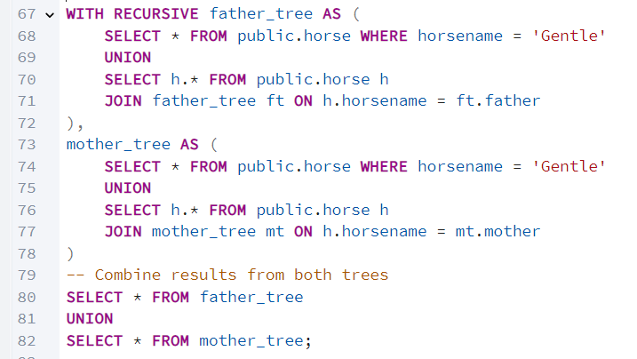

Slide 7
N1
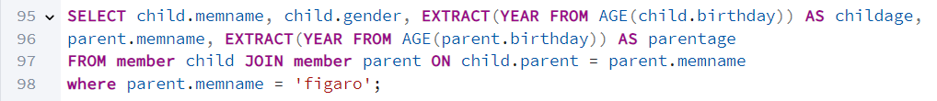

N2
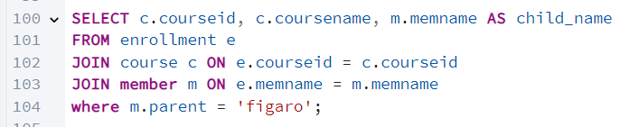

Slide 8
N1
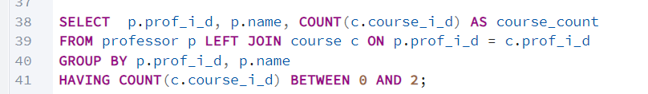

N2
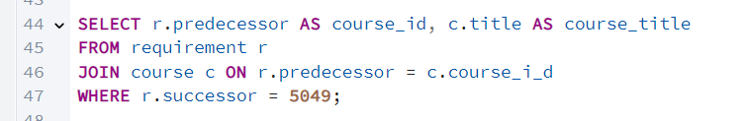

N3
